Architectural Components - Mappers

📝Definition
# Source: AI Source: Provided by: [Data Path: Persons Table -> ID Column: 1, Name_En Column: Motasem Essam] -> From: [ChatGPT] on [1/23/2026]
Mappers are components responsible for converting data between different layers or models in an application.
👉 They act as translators between representations (e.g., Domain Model ↔ DTO ↔ Database Entity)

🔑 Key Idea
# Source: AI Source: Provided by: [Data Path: Persons Table -> ID Column: 1, Name_En Column: Motasem Essam] -> From: [ChatGPT] on [1/23/2026]
- Different layers use different data structures
- Mappers convert data without mixing responsibilities

🧱 Common Conversions
# Source: AI Source: Provided by: [Data Path: Persons Table -> ID Column: 1, Name_En Column: Motasem Essam] -> From: [ChatGPT] on [1/23/2026]
- Entity ↔ DTO
- Model ↔ ViewModel
- API Response ↔ Domain Model

🧩 Example

Domain Model
# Source: AI Source: Provided by: [Data Path: Persons Table -> ID Column: 1, Name_En Column: Motasem Essam] -> From: [ChatGPT] on [1/23/2026]
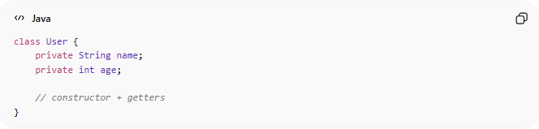
class User {
private String name;
private int age;

// constructor + getters
}

DTO (Data Transfer Object)
# Source: AI Source: Provided by: [Data Path: Persons Table -> ID Column: 1, Name_En Column: Motasem Essam] -> From: [ChatGPT] on [1/23/2026]
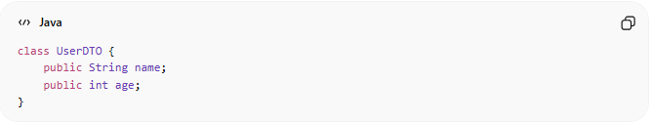
class UserDTO {
public String name;
public int age;
}

Mapper
# Source: AI Source: Provided by: [Data Path: Persons Table -> ID Column: 1, Name_En Column: Motasem Essam] -> From: [ChatGPT] on [1/23/2026]
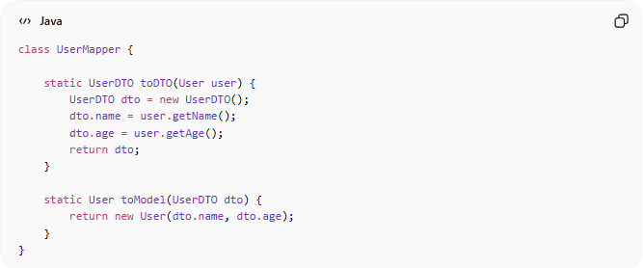
class UserMapper {

static UserDTO toDTO(User user) {
UserDTO dto = new UserDTO();
dto.name = user.getName();
dto.age = user.getAge();
return dto;
}

static User toModel(UserDTO dto) {
return new User(dto.name, dto.age);
}
}

❌ Bad Example (No Mapper)
# Source: AI Source: Provided by: [Data Path: Persons Table -> ID Column: 1, Name_En Column: Motasem Essam] -> From: [ChatGPT] on [1/23/2026]
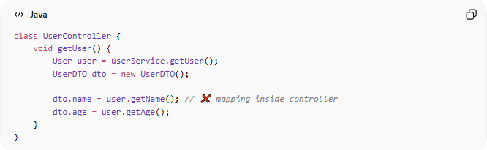
class UserController {
void getUser() {
User user = userService.getUser();
UserDTO dto = new UserDTO();

dto.name = user.getName(); // ❌ mapping inside controller
dto.age = user.getAge();
}
}
👉 Problems:
- Violates Single Responsibility Principle (SRP)
- Code duplication
- Hard to maintain

✅ Good Example (Using Mapper)
# Source: AI Source: Provided by: [Data Path: Persons Table -> ID Column: 1, Name_En Column: Motasem Essam] -> From: [ChatGPT] on [1/23/2026]
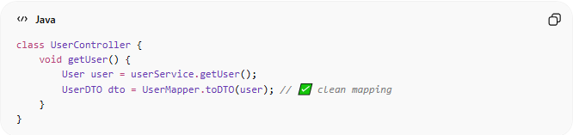
class UserController {
void getUser() {
User user = userService.getUser();
UserDTO dto = UserMapper.toDTO(user); // ✅ clean mapping
}
}
👉 Benefits:
- Cleaner code
- Reusable mapping logic
- Easier to maintain

🔄 Where Mappers Are Used
# Source: AI Source: Provided by: [Data Path: Persons Table -> ID Column: 1, Name_En Column: Motasem Essam] -> From: [ChatGPT] on [1/23/2026]
- MVC / MVVM → Convert Model ↔ ViewModel / DTO
- Clean Architecture → Between layers (Domain ↔ Data ↔ Presentation)
- DDD → Map Entities ↔ DTOs ↔ Persistence models

⚠️ Common Mistakes
# Source: AI Source: Provided by: [Data Path: Persons Table -> ID Column: 1, Name_En Column: Motasem Essam] -> From: [ChatGPT] on [1/23/2026]
- Mixing mapping logic inside Controller/Service ❌
- Overcomplicating simple mappings ❌
- Adding business logic inside Mappers ❌

💡 Key Idea
# Source: AI Source: Provided by: [Data Path: Persons Table -> ID Column: 1, Name_En Column: Motasem Essam] -> From: [ChatGPT] on [1/23/2026]
Mappers only transform data, they do NOT contain business logic

🧾 Summary
# Source: AI Source: Provided by: [Data Path: Persons Table -> ID Column: 1, Name_En Column: Motasem Essam] -> From: [ChatGPT] on [1/23/2026]
Mappers:
- Convert data between layers
- Keep code clean and separated
- Improve maintainability and reuse

